AMBER SHUKLA
A8-B3_42
CSE CORE
EXP-4

4 | Demonstrate the use of function and recursion in C Programming Language by implementing following programs:  - Write a C program to print the sum of following series using user defined function:  Series: 1/1! + 2/2! + 3/3! + 4/4! + ... N/N!  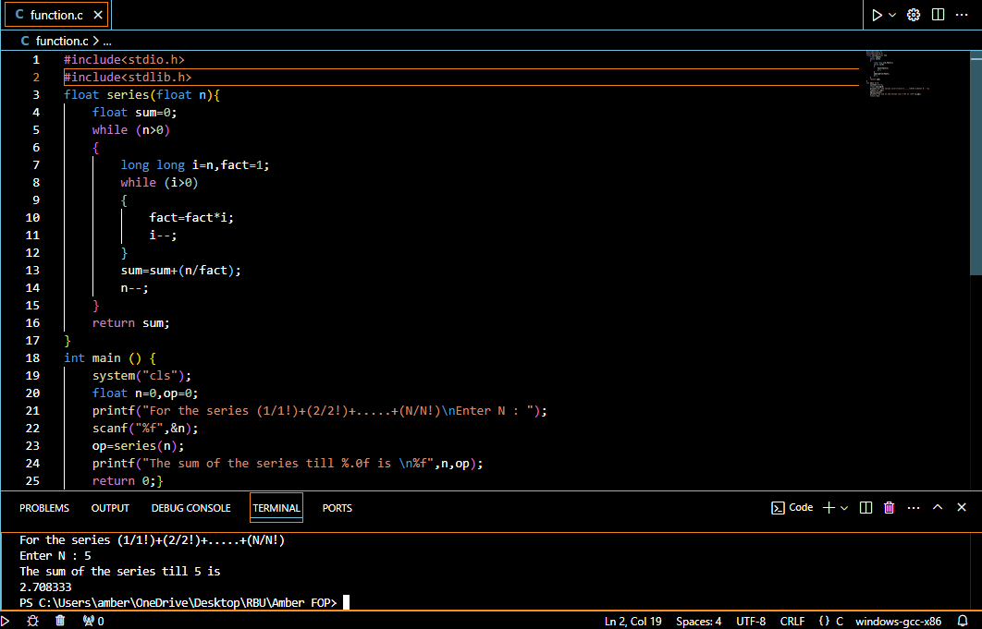  - In Fibonacci series the next number is the sum of previous two numbers i.e. 0, 1, 1, 2, 3, 5, 8, 13, 21 …. The first two numbers of Fibonacci series are 0 and 1. Write a C program to print the Fibonacci series using recursion.  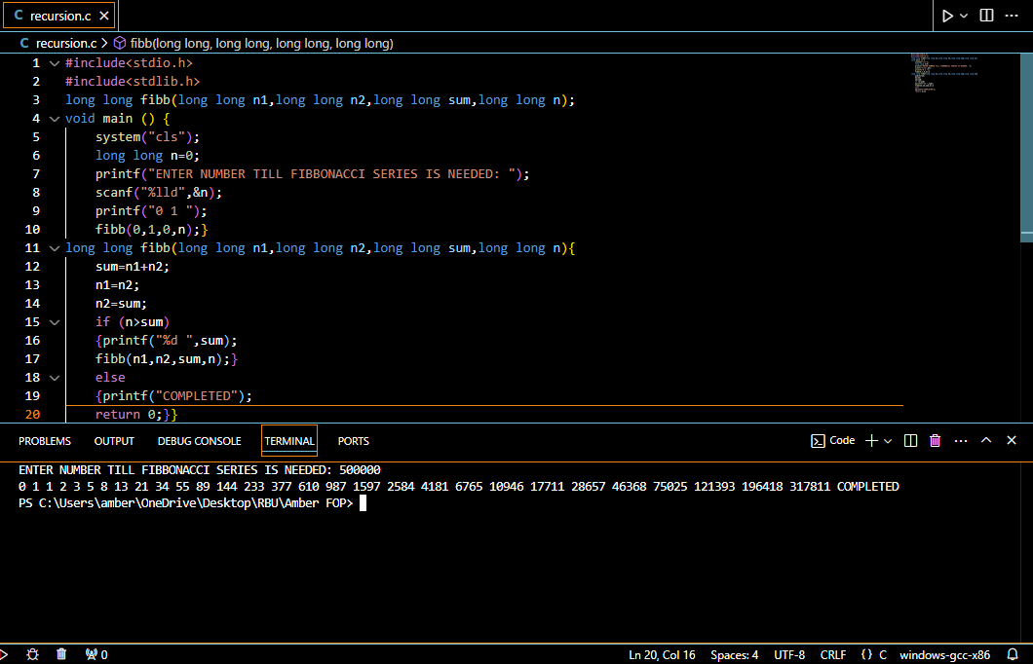 | CO1

